PrintsCapture User Guide
For Livescan


Version 1.0
May 2015

For assistance, send an email to:
support@xl-id.com

Table of Contents
1 Changes and Modifications 1
2 Scanner Installation 1
3 Workflow 1
4 Windows 2
4.1 Device Configuration Window 2
4.2 Main Window 3
4.3 Finger Condition Window 5
4.4 Scanning Window 6
4.5 Information Window 7
4.6 Consent Window 8
5 Advanced Features 9
5.1 Option Tab 9
5.1.1 Sequence 9
5.1.2 Quality 9
5.1.3 Crop 9
5.1.4 Overrides 9
5.2 Troubleshouting Tab 10

Changes and Modifications
The table below lists the changes made to the PrintsCapture User Guide:
Version | Changes/Modifications | Pages
1.0 | Initial release. | All pages

Application Description
PrintsCapture is a Windows application to capture prints with a scanner device. It ensure that prints processed from the scanner meets some quality requirements. It is designed to be easy to use and has a standard appearance for all scanners.
The application allow to easily identify missing fingers and see swiftly which images are not right.
This application is called by UniDAC to allow secure transfer of fingerprint images into a secure database. It can be used for livescan, meaning that a person can put their hand on the platen of a scanner and be fingerprinted live. It can also be used for cardscan, where a person send a document where her fingerprints are on a sheet of paper, also called a card, and must be scanned by a flatbed scanner.

Scanners
The application supports many scanners, but not all of them are certified for each use. Only use scanner that certified and ask us for a quote to add scanner to your system.

Livescan scanners from Crossmatch
Currently, there are 2 scanners that are certified for flat print capture. The Guardian Usb and the Patrol Id. There are plan to include the 1000px and the Patrol models.
The Crosstmach Essentials runtimes version 7 must be installed in order to allow scanner communication to the application. All scanners, except 1000 models, work with Usb 2 ports. The 1000px works with a firewire plug.

Livescan scanners from Identification International Inc (I3)
There is only the DigID+ certified for flat print capture. There are no plan to support any other as of now.
The DigID drivers must be installed (TO CONFIRM ONLY SDK WAS PROVIDED) to allow scanner communication with the application.

Cardscan scanners
Currently, we plan on supporting the V500, V550 and V700 Epson scanner for card scanning.
Those devices need the Epson scan software installed and working to communicate with the application.

Workflow
To capture properly the application and return quality prints, follow these simple steps. Additional details are provided for each Window in section 5.
A) Configure the device, which will appear when no device is configured. After the first capture, this is no more needed.
B) Identity the fingers that cannot be scanned, if any. It is important that this is done before scanning begins.
C) Scan the prints.
D) Capture the fingerprinted person endorsement.
E) End the capture.

The first window to appear will be the device configuration. It appears only on the first use and will not be shown in subsequent use, unless the button is clicked.
The main Window will be shown next. Before starting the capture, make sure all missing fingers are flagged correctly. If a missing finger was not set, you will have to use the reset button, flag the missing part and start over.
Click on scan to start the capture. All needed fingerprints will be asked in order, depending on capture mode.
Flat prints: Left four, right four, two thumbs.
Rolled: Left four, Right four, Left thumb flat, Right thumb flat. Left index to little rolled. Right index to little rolled. Left thumb rolled. Right thumb rolled.
If any prints shows red status, click on them to see all the information about the print. It is recommended to scan the print again until the print pass the quality and sequence checks.
When all prints are green or yellow, an endorsement finger could be captured. It is required for any Rcmp delivery to someone else than the person whose fingerprints were taken.
When all prints are done, you can click on the end button. A confirmation prompt will be shown to make sure you are done.

Windows

Device Configuration Window
This window allow to select and configure the scanner.
It will automatically appear on first use. After, you must click on the configure button on the main window.
By pressing the auto-detect button, the application will try to find a compatible device currently attached and powered. Unless told otherwise, all options should stay to their default value.
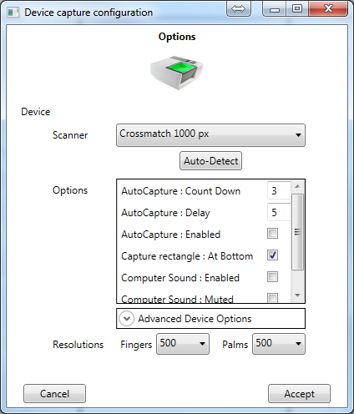
Some hardware vendor tools are included in the advanced device option.
RCMP currently only supports 500 Dpi, so the resolution should not be changed.

Main Window
The main window contains all operations, image status and finger information. It displays information and status of pending operations.
The current screen is for flat print capture. See notes for other modes.
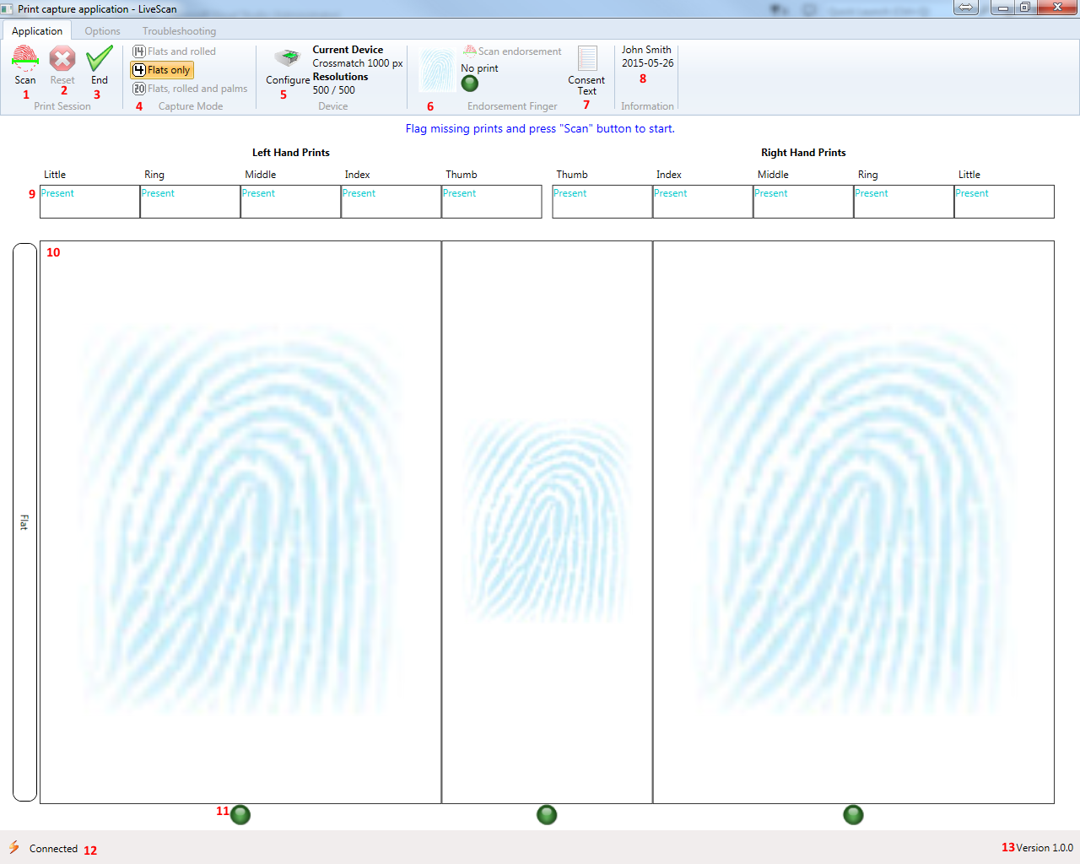
To flag a print or see the print information, click on status label, status icon or print image.
- This button starts the scan sequence. The scanning window will appear after the service has started a session.
- This button resets a scan session in progress, removing all fingerprints. It is necessary if a finger is missing and has not been set before the scan was started.
- This button ends the capture if all images status are ok. A confirmation will be asked before closing the application. If any prints are not ready, list of prints to correct will be shown.
- The capture mode available are listed here. For Canadian civilan purpose, only the flat prints are allowed in this version.
- This button opens the device capture configuration window.
- This section shows current endorsement finger name and status.
- This button display the consent text for the fingerprinted person to read.
- The information section display the description given by the calling application.
- This line shows the status of each individual finger.
- This section show the image of the scanned prints. When an actual print has been captured, it’s image will be shown.
- Theses icons display the current status. Orange: validation is in progress. Red: validation have failed. Checkmark: Validation completed. Yellow: Manually accepted. Clicking on the icon or image will open either the finger status or the print information.
- The service connection status. If your connection is lost, it can be resumed. Double clicking on the lightning icon will try to reconnect and resubmit all prints.
- The application version.

For capture mode other than flat, blank prints are displayed instead of status text and the actual scanned print is shown after scan. However, missing prints can be flagged the same say. Once flagged, the missing reason and date will be displayed instead of the blank print.

Finger Condition Window
This window allow to choose the missing reason and enter the condition date.
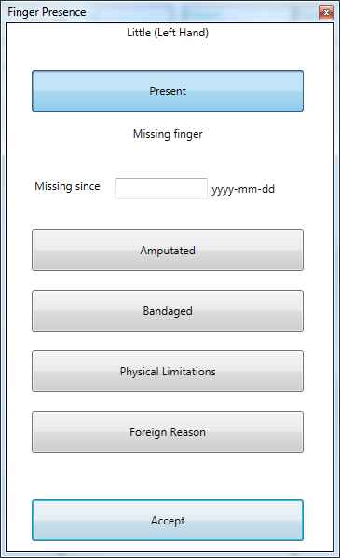
The default condition is “Present”, meaning the finger will be captured as normal. If it cannot be scanned, a condition must be chosen, and if possible a date or partial date should be entered. A partial date can be the year alone or the year and the month.
- Amputated: Body part was amputated.
- Bandaged: Body part is bandaged and cannot be scanned at this time.
- Physical limitation: A condition prevent placing the body part on the scanner platen.
- Foreign reason: Another reason prevent scanning the body part.

Scanning Window
This window gives the scanning instructions. It show the scanning process, the preview image and device messages. It allows to easily rescan a print.
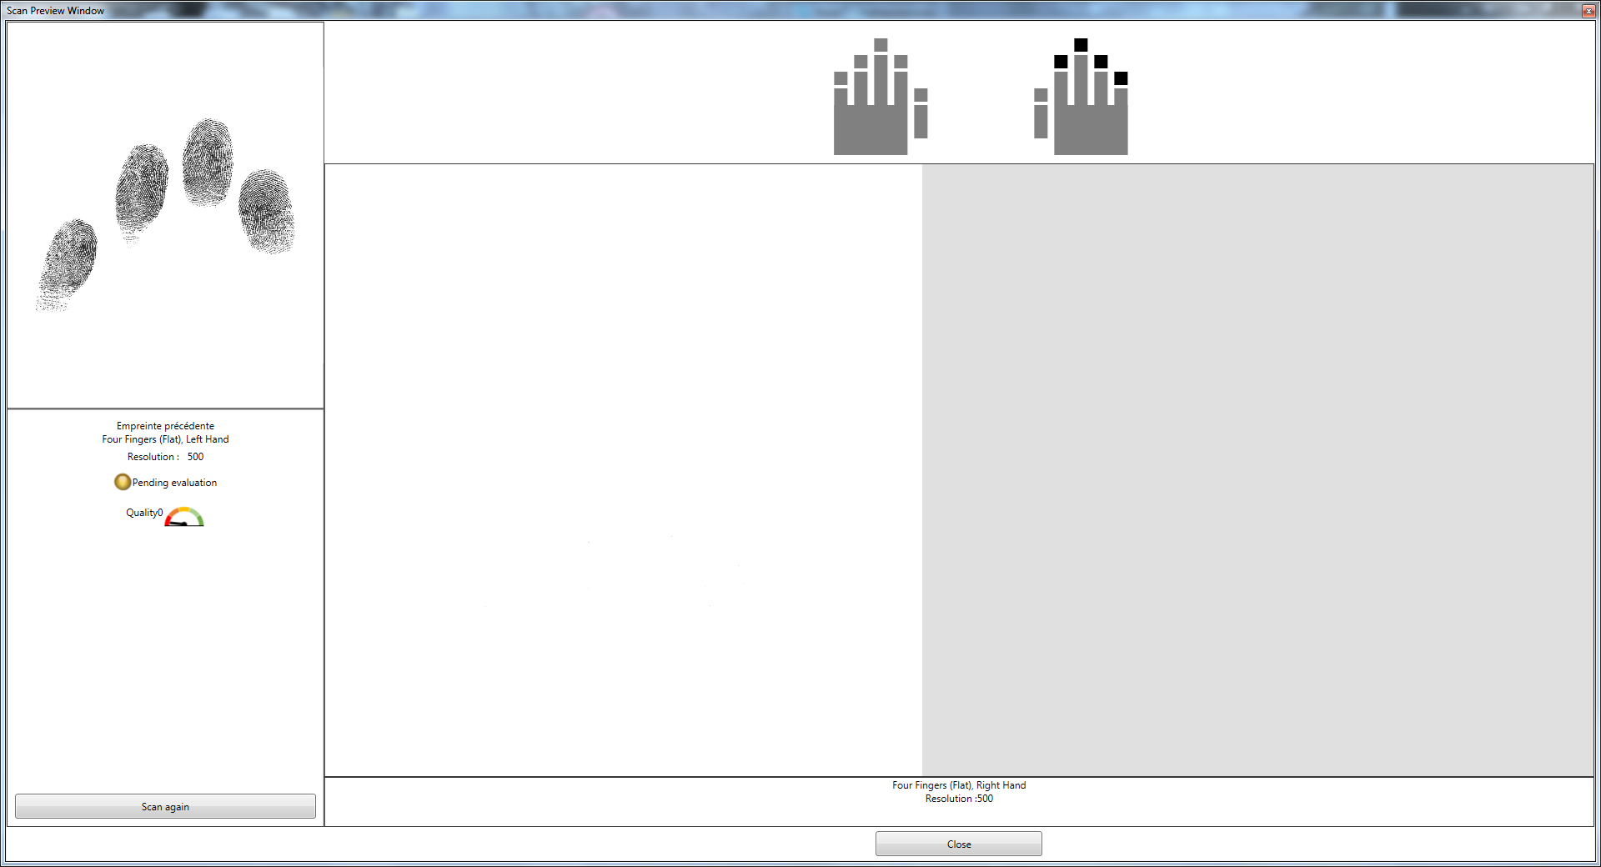
At the top, the needed finger part are shown by black boxes. Those boxes become green, yellow or red depending of the quality of the print. When all parts are green, the capture is triggered. Not all scanners support quality preview, so the boxes could stay black. In that case, the trigger is to stay idle for a short amount of time.
At the top left corner is the previously scanned print image. Below is the print information and status. Note that the quality and sequence are checked asynchronously. It is recommended to capture all prints and then verify quality and sequence. It is always possible to scan a print again, even outside this window.
The center section shows the preview of the scan process going on.
Near the bottom is the written instruction telling exactly what to do.
After a print was scanned, it moves to the next print until all prints are scanned (save the endorsement finger).
The process can be stopped anytime by pressing the close button.

Information Window
This window show the scan print and all relevant information. It allows to override a print that do not match quality standard with a message so print set will be accepted.
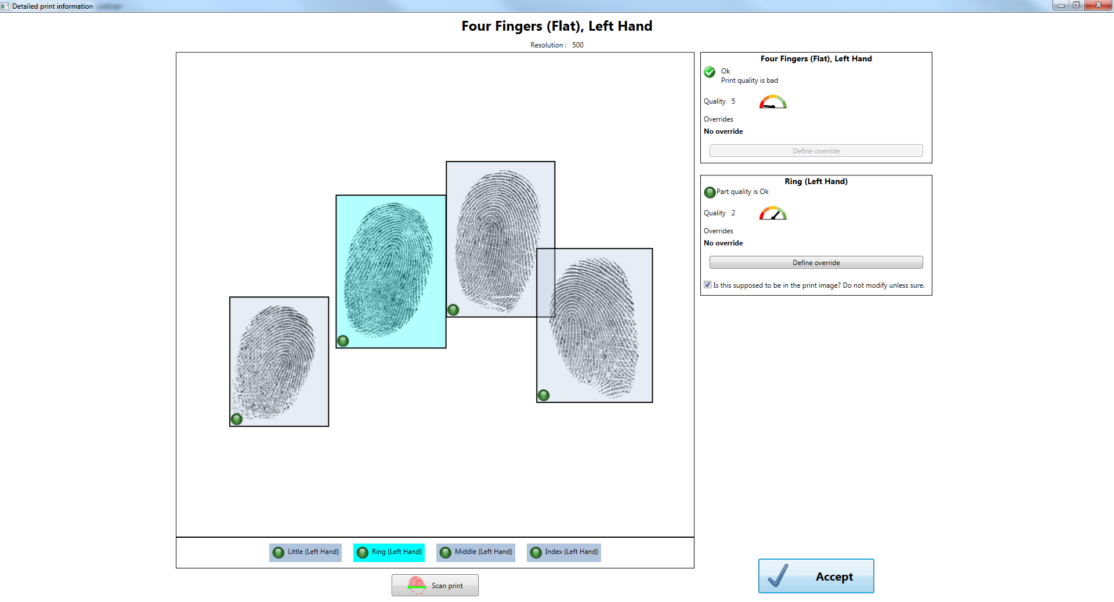
At the top, the part name and the resolution at which it was scanned are displayed.
In the center is the print. When Flat prints are scanned (Civilian purpose only), each print part is boxed and the name of each part is displayed at the bottom of the image. You can select parts by clicking on them or on their name.
At the top right corner, the print information is displayed. The quality score and sequence score are shown with an indicator. If they are below the threshold, a message is displayed and the status icon will not be green. If this is the case, but the print will not get better, an override can be applied. This will allow the fingerprints to be saved. Note: In flat prints, only hand part can be overridden.
Below at the right is the part information, for some prints only. The selected part information is shown, if any is selected. The information displayed is the same, save for a checkbox. This checkbox allow to ignore a print that is present in the flat but not on his rolled counterpart. It should remain checked unless you have a good reason to uncheck it.
Some buttons are displayed for specific actions below the prints. The most common one is “Scan print” and allow to rescan this specific print.
The accept button commits the change to the print set service. If not clicked, all changes are ignored.

Consent Window
This window allow the individual to read or to be read the consent of giving an endorsement finger
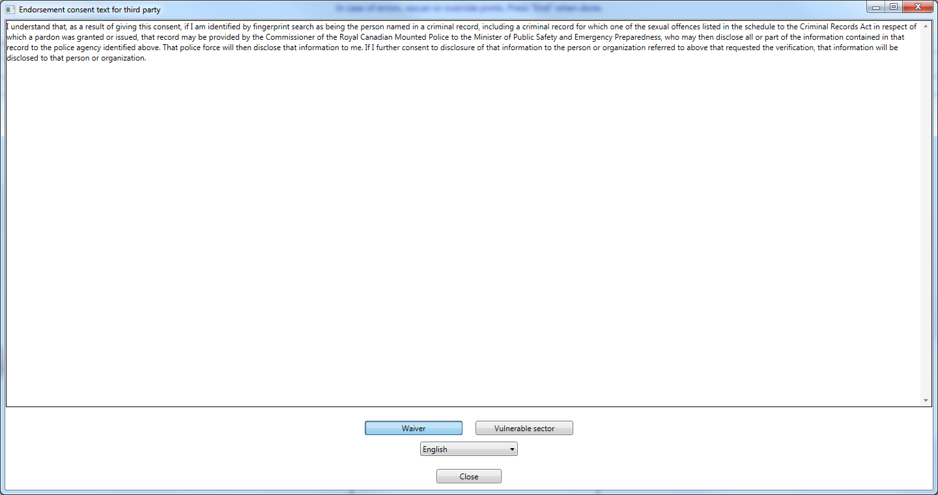
There are two types of consent: 3rd party waiver and vulnerable sector consent. Click on the one corresponding to the current situation.
There is a language displayed. Changing it will change the text of the consent only. Useful when people want to read the consent themselves in their own language.
The close button closes the window.

Advanced Features
Advanced features are not accessible by default. Options should stay at their default values, unless told otherwise by the Rcmp Or Solutions XL-ID.

Option Tab
This tab allow to customize quality and sequence validation. It allows some rules for overriding prints.
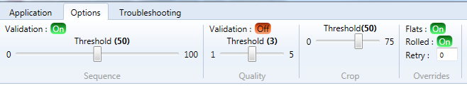

Sequence
The sequence part allow to set the threshold for the sequence check and to enable/disable the validation.
A score of 50 is good enough, where 100 requires fingerprint of excellent quality and 10 is a poor match.
When deactivated, prints will appear ok, but the status text will tell you if a print sequence is below threshold.
It is not recommended to deactivate the sequence check, as it is the primary way of verifying prints integrity. Note that Rcmp will do their own check on the prints. They will reject the transaction if faulty prints are sent.

Quality
The quality part allow to set the threshold and enable/disable the validation.
A score of 1 is an excellent quality print and a score of 5 is the worst possible quality.
When deactivated, prints will appear ok, but the status text will tell you if a print quality is below threshold.
By default, the validation is deactivated because many person have bad fingerprints, due to age and work.

Crop
Not used for Livescan purpose.

Overrides
This part allow to set override for flats and rolled and a threshold required to allow override.
When flats are enabled, it means that left four, right four and flat thumbs can be overridden. Does not apply to flat mode capture.
When rolled are enabled, it means that all rolled prints can be overridden. Else the override option is not available. It is not recommended to disable rolled print override.
Retry: Number of time a print must be scanned before an override can be allowed, if override has not been disabled in the previous options.

Troubleshouting Tab
This tab allow to face some problems with a solution to save your work or restart service connection.
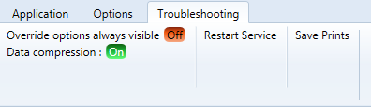
Override options always visible: Makes the override option enable even when application rules would prevent it.
Data compression: Allow data compression to send information to service. Prints are zipped when compressed, else are sent as bmp.
Restart service: Restart the connection to the service. All prints are sent back to the service.
Save Prints: Save the scanned prints to a folder on the local computer as Bitmap images.

